3GPP TSG-RAN WG4 Meeting#119 R4-2606885
Dalian, CN, May 18 - 22, 2026
Agenda item: 8.10.3
Source: ZTE Corporation, Sanechips
Title: Discussion on feasibility study for 6G sensing
Document for: Approval
- Introduction
In RAN#108 meeting, a new SID on Study on 6G Radio [1] was approved. In this contribution, we would like to share some further understandings on 6GR ISAC study.
- Sensing – Studies to be based on use cases and associated requirements, as defined in [TR38.914]
- PHY functions and procedures for sensing technology (e.g., waveform. reference signals, measurement feedback, etc…) [RAN1, RAN4]
- Evaluate sensing performance and if necessary, extend channel modelling, for the selected use cases [RAN1]
- Aspects of integration with communication services [RAN1]
- higher layer procedures and protocol aspects [RAN2]
- RAN4 aspects of sensing including RF, coexistence, and testability in coordination with other WGs [RAN4]
Note: RAN1 identify detailed requirements, if triggered by TSG RAN
RAN4#116bis:
Agreement:
Before April 2026, the agenda for sensing will be kept. RAN4 discussion will primarily focus on the following aspect
- Sensing related regulatory status and requirement survey
- Potential architecture consideration based on the RAN plenary use case study
- views sharing on the potential RAN4 scope based on the identified use cases out of RAN plenary study
- Identify less RAN1 design dependent RAN4 aspects if any

- Discussion

2.1. General
There are 7 different sensing mode as discussed in the previous RAN plenary meeting, these sensing mode was not decided yet, this should be up to RAN1’s further discussion from our understanding even though there were some RAN plenary discussion before. In the following table, we shared some initial views on the RF feasibility for each sensing mode.
Table 2.1-1: RF feasibility for each sensing mode
Sensing mode | RF feasibility
TRP mono-static | Solution 1: TDM method. For this solution, there are no much feasibility issues since Tx and Rx are not working simultaneously, TDD ON-OFF transition period might need to be revisited since large switching time will cause lager blind detection areas in the airspace close to the sensing TRP.  Solution 2: Full duplexer method. For this solution, then TRP should support the full duplex mode to have Tx and Rx operating simultaneously. Similar as SBFD operation, the RF feasibility should be provided.  Details could be found in Section 2.2.
TRP bi-static | TRP Tx and Rx is not working simultaneously, therefore there are no much feasibility problems, however from the timing sync performance from two TRPs should be further discussed since the current timing error among different TRPs are 3us which is way too relaxed for sensing operation.
TRP-UE bi-static | Whether the location information of TRP could be accessible to UE side;  Whether the DL timing estimation error from UE has big impacts on the measurement accuracy. The existing UL timing error requirement is partially decided by DL SSB timing estimation error.
UE-TRP bi-static | Whether the location information of UE could be accessible to UE side due to the personal information privacy;  Whether the UL timing estimation error from UE has big impacts on the measurement accuracy. The existing UL timing error requirement is partially decided by DL SSB timing estimation error.  NOTE: this case is similar as Rel-17 SRS transmission based positioning, not sure any major difference.
UE monostatic | Similar as TRP mono-static
UE bi-static | Similar as TRP bi-static
Proposal 1: For the feasibility study for 6G sensing, propose to discuss this issue according to different sense mode as shown the above table.

2.2. Architecture and RF feasibility for 6G TRP mono-static
In the following section, we would like to share our detailed views on the potential RF architecture for solution 1 and solution 2 as mentioned above.
For the RF hardware assumption of solution 1 as shown in Figure 2.2-1, although it is expected to work as TDD BS, however it will go to receive the backscattering signal from the sensing target or potential co-channel interference from other sensing BS transmitting signals, therefore in RAN4, we also need to further consider the RF feasibility evaluation from the receiver’s in-channel linearity and also out of carrier blocking performance.
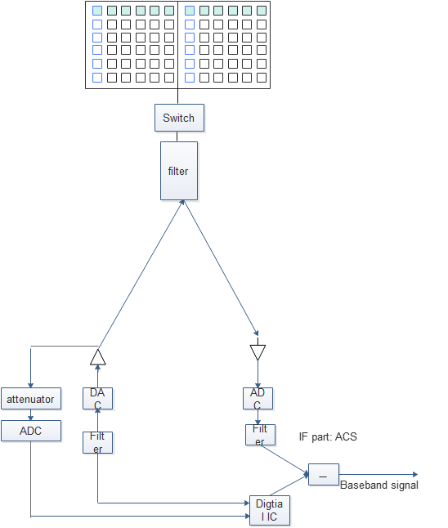
Figure 2.2-1. Illustration of RF architecture for pulse wave signal [similar to the legacy TDD BS]
Proposal 2: For the TRP mono-static with solution 1 TDM operation, consider the RF feasibility evaluation from the receiver’s in-channel linearity and also out of carrier blocking performance.
For the generic baseband signal generation of option 1 as shown in Figure 2.2-2, it is somehow similar to LP-WUS signal generation to create the short pulse signal to minimize the blind detection regions.
Figure 2.2-2 Generation of pulse signal by traditional DFT-s-OFDM waveform [3]
For the RF hardware assumption of solution 2 as shown in Figure 2.2-3, this is similar to SBFD RF architecture as specified in Rel-19. To enable this sensing feature, the Tx/Rx panels are separated to ensure the large isolation to minimize the receiver impacts. In addition, the sensing operation is full carrier transmission instead of DL sub-band transmission which is one significant difference compared with Rel-19 SBFD operation.
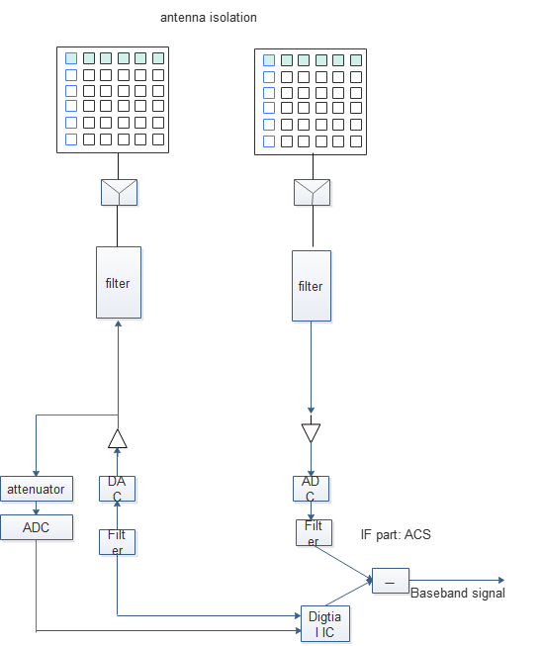
Figure 2.2-3. Illustration of RF architecture for contiguous wave signal [similar to Rel-19 SBFD digital IC calibration process]
Proposal 3: For the TRP mono-static with solution 2 full duplex operation, consider the following example table to check its RF feasibility including fully overlapping transmission/reception between DL and UL.
FR1 |  |  |  | ZTE
BS class |  |  |  | Wide  Area BS  Full duplex mode
BS TX Power $dB\left(P_{TX}\right)$ = ① dBm |  |  |  | 38 dBm
Component  capability and parameters | Frequency isolation at TX | Frequency isolation capability $dB\left(α_{SI−frequency, TX}\right)$ = ② dBc |  | N/A
 |  | Frequency isolation  techniques used |  | N/A
 | Spatial isolation | Spatial isolation capability  $dB\left(α_{SI−spatial}\right)$ = ③ dBc |  | 65 dBc
 |  | Spatial isolation  techniques used |  | TX/RX panel separation and RF barrier structure
 | TX Beam nulling /isolation in TX sub-band  $dB\left(α_{SI−beam}\right)$= ④ dBc |  |  | TBD
 | DL EIRP impact due to beam nulling in TX sub-band |  |  | Limited, ~0dB
 | Self-interference leakage in gNB RX subband due to non-ideal TX, measured at RX ant. $dB\left(P_{SI_leakage}\right)$ (Note 1) |  |  | Note: provided by  ①-②-③-⑨ dBm
 | RF IC and other tech. (before LNA) | RF IC capability and other tech. in TX sub-band $dB\left(α_{SI−RFIC}\right)$ = ⑤ dBc |  | N/A
 |  | RF IC capability and other tech. in RX sub-band $dB\left(α_{SI−RFIC}\right)$ = ⑧ dBc |  | N/A
 |  | RF IC techniques and other tech.  (before LNA) |  | N/A
 |  | Impacts to RX sensitivity (due to e.g. insertion losses) due to RF IC or other techniques before LNA |  | N/A
 | Self-Interference signal in gNB TX subband, measured at the input of LNA $dB\left(P_{SI_TXSB}\right)$ (Note 1) |  |  | TBD  Note: provided by  ①-③-④-⑤dBm
 | Blocker Suppression at RX | Frequency isolation capability  $dB\left(α_{SI−frequency, RX}\right)=$⑥ dBc |  | N/A
 |  | Frequency isolation techniques |  | N/A
 |  | RX IMD | Rx IIP3 capability (dBm) | TBD
 |  |  | Rx IM3 contribution (dBm)
 |  | Other RX | Any other RX impacts if significant (e.g. ADC noise, phase noise etc.) | N/A
 | Self-Interference signal in gNB RX subband caused by non-ideal RX selectivity, gain-normalized  $dB\left(P_{SI_Selectivity}\right)$(Note 1, 2) |  |  | TBD  Note: provided by  ①-③-④-⑤-⑥dBm
 | RX Beam nulling /isolation in RX sub-band  $dB\left(α_{SI−beam}\right)$= ⑨ dBc |  |  | TBD
 | RX sensitivity degradation caused by RX beam nulling |  |  | TBD
 | Digital IC $dB\left(α_{SI−digtial}\right)$ = ⑦ dBc |  |  | TBD
Overall RSIC capability $dB\left(RSIC\right)$ (Note 1) |  |  |  | TBD
Noise floor ⑩dBm |  |  |  | TBD/100MHz
Residual Interference budget with 1 dB desens target (⑪dBm=⑩dBm-6dB) |  |  |  | TBD
Required RSIC budget (①-⑪dBc) |  |  |  | TBD
Guardband assumption (if exist) |  |  |  | N/A
bandwidth over which suppression is achieved |  |  |  | 100MHz
Others

FR2 |  |  |  | ZTE
BS class |  |  |  | Wide  Area BS  Full duplex mode
BS TX Power $dB\left(P_{TX}\right)$ = ① dBm |  |  |  | TBD dBm
Component  capability and parameters | Frequency isolation at TX | Frequency isolation capability $dB\left(α_{SI−frequency, TX}\right)$ = ② dBc |  | N/A
 |  | Frequency isolation  techniques used |  | N/A
 | Spatial isolation | Spatial isolation capability  $dB\left(α_{SI−spatial}\right)$ = ③ dBc |  | 65 dBc
 |  | Spatial isolation  techniques used |  | TX/RX panel separation and RF barrier structure
 | TX Beam nulling /isolation in TX sub-band  $dB\left(α_{SI−beam}\right)$= ④ dBc |  |  | TBD
 | DL EIRP impact due to beam nulling in TX sub-band |  |  | Limited, ~0dB
 | Self-interference leakage in gNB RX subband due to non-ideal TX, measured at RX ant. $dB\left(P_{SI_leakage}\right)$ (Note 1) |  |  | Note: provided by  ①-②-③-⑨ dBm
 | RF IC and other tech. (before LNA) | RF IC capability and other tech. in TX sub-band $dB\left(α_{SI−RFIC}\right)$ = ⑤ dBc |  | N/A
 |  | RF IC capability and other tech. in RX sub-band $dB\left(α_{SI−RFIC}\right)$ = ⑧ dBc |  | N/A
 |  | RF IC techniques and other tech.  (before LNA) |  | N/A
 |  | Impacts to RX sensitivity (due to e.g. insertion losses) due to RF IC or other techniques before LNA |  | N/A
 | Self-Interference signal in gNB TX subband, measured at the input of LNA $dB\left(P_{SI_TXSB}\right)$ (Note 1) |  |  | TBD  Note: provided by  ①-③-④-⑤dBm
 | Blocker Suppression at RX | Frequency isolation capability  $dB\left(α_{SI−frequency, RX}\right)=$⑥ dBc |  | N/A
 |  | Frequency isolation techniques |  | N/A
 |  | RX IMD | Rx IIP3 capability (dBm) | TBD
 |  |  | Rx IM3 contribution (dBm)
 |  | Other RX | Any other RX impacts if significant (e.g. ADC noise, phase noise etc.) | N/A
 | Self-Interference signal in gNB RX subband caused by non-ideal RX selectivity, gain-normalized  $dB\left(P_{SI_Selectivity}\right)$(Note 1, 2) |  |  | TBD  Note: provided by  ①-③-④-⑤-⑥dBm
 | RX Beam nulling /isolation in RX sub-band  $dB\left(α_{SI−beam}\right)$= ⑨ dBc |  |  | TBD
 | RX sensitivity degradation caused by RX beam nulling |  |  | TBD
 | Digital IC $dB\left(α_{SI−digtial}\right)$ = ⑦ dBc |  |  | TBD
Overall RSIC capability $dB\left(RSIC\right)$ (Note 1) |  |  |  | TBD
Noise floor ⑩dBm |  |  |  | TBD/100MHz
Residual Interference budget with 1 dB desens target (⑪dBm=⑩dBm-6dB) |  |  |  | TBD
Required RSIC budget (①-⑪dBc) |  |  |  | TBD
Guardband assumption (if exist) |  |  |  | N/A
bandwidth over which suppression is achieved |  |  |  | 200MHz
Others

2.3. Architecture and RF feasibility for 6G TRP bi-static
For The TRP-bistatic sensing mode, the sensing BS is expected to be similar as the legacy BS unless the angle/positioning estimation accuracy necessitates the larger antenna array size for 6G sensing. RAN4 needs to focus on the timing synchronization performance(e.g. 3us or +/-1.5us) among different TRPs.
From our understanding, the non-sync timing performance among different TRP nodes could be somehow mitigated by calculating the TRP internal time difference for LOS/direct link and reflected link between TRP-sensing target- TRP and further use these timing difference information to calculate the timing difference among different TRP nodes.
In addition, the potential BS2BS CLI problem within the carrier should be also investigated whether the higher input power within the carrier will cause the blocking issues.
Proposal 4: For the TRP bi-static sensing mode, propose to discuss the impacts of potential timing synchronization performance on the sensing results and also the impacts of 6G sensing signal on blocking performance within the carrier.

2.4. Architecture and RF feasibility for 6G TRP-UE bi-static
Please see the analysis in Table 2.1-1 and more detailed analysis are provided as following.
- UE DL timing estimation
In the past, from UE side, we mainly focus on the UE UL transmitting timing requirement to ensure the network performance. However it should be known that UL transmit timing requirement is also dominated by DL SSB estimation error, UE clock drift, TA command quantization and Timing Advance adjustment accuracy. For 6G sensing measurement, whether it is the raw channel estimation results or processed measurement results to be reported to TRP side, it is up to RAN1’s decision. However from RAN4 DL timing accuracy perspective, if the timing difference between two paths are smaller than 1/BW, then these two paths cannot be distinguished at the end, therefore in order to achieve the target range estimation resolution, UE DL timing performance and UE DL timing difference among different UEs for the same target object measurement should be also considered.
Proposal 5: For TRP-UE bi-static sensing mode, propose to discuss the per UE DL timing performance and DL timing difference among different UEs for the same target object measurement and its impacts on the sensing results.
- UE maximum dynamic range
For the NR UE, the dynamic range requirement is mainly decided by maximum input power (e.g.FR1 -25dBm) and REFSENS requirements (e.g. FR1 -90.8 + 10log₁₀(N_{RB}/51) for band n104 and -96.1 + 10log₁₀(N_{RB}/24 for band n79), however for the received sensing signal from UE side, it will be reflected by passive target object, the expected pathloss will be higher than the normal communication link and the corresponding received power for sensing signal would be expected to be lower than REFSENS requirements, in the words, the receiver dynamic range might be expected to be higher than the legacy NR UE. So far, there are no available simulation results to justify this potential trends, we propose to discuss this issue until there are sufficient evaluation results from the SLS simulation evaluation in RAN4.
Proposal 6: For TRP-UE bi-static sensing mode, propose to discuss UE’s receiver dynamic range issue until there are sufficient evaluation results from 6G sensing SLS simulation evaluation.
- The impacts of I/Q imbalance on the doppler shifter estimation
In last RAN4 meeting, there are some proposals mentioning that spectrum regeneration (spurious peaks) due to the IQ imbalance will generate the false targets. In this following Figure, we provided some initial simulation results to justify this potential impacts on this false target. This is true that there will be some blue spurious spur due to the IQ imbalance at the end, however this is not something new to general doppler frequency estimation and not sure the impacts on the sensing measurement results.
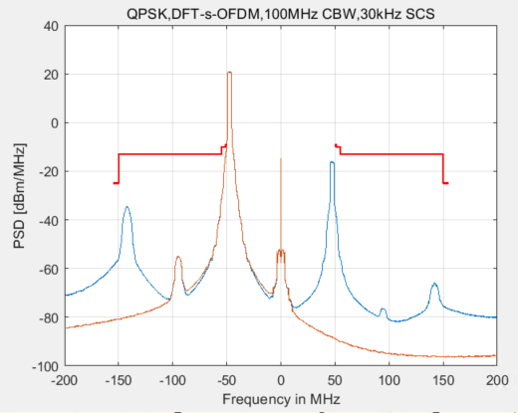

2.5. Architecture and RF feasibility for 6G UE-TRP bi-static
Please see the analysis in Table 2.1-1 and more detailed analysis (e.g. UL timing error impacts) would be provided later on once the sensing mode is confirmed in RAN4.

2.6. Architecture and RF feasibility for 6G UE-UE mono-static
Please see the analysis in Table 2.1-1 and more detailed analysis could be provided later on once the sensing mode is confirmed in RAN4.

2.7. Architecture and RF feasibility for 6G UE-UE bi-static
Please see the analysis in Table 2.1-1 and more detailed analysis could be provided later on once the sensing mode is confirmed in RAN4.
- Conclusions
In this contribution, we shared some initial views on the 6GR ISAC study and proposals are made as follows:
Proposal 1: For the feasibility study for 6G sensing, propose to discuss this issue according to different sense mode as shown the above table.
Sensing mode | RF feasibility
TRP mono-static | - Solution 1: TDM method. For this solution, there are no much feasibility issues since Tx and Rx are not working simultaneously, TDD ON-OFF transition period might need to be revisited since large switching time will cause lager blind detection areas in the airspace close to the sensing TRP.  - Solution 2: Full duplexer method. For this solution, then TRP should support the full duplex mode to have Tx and Rx operating simultaneously. Similar as SBFD operation, the RF feasibility should be provided.
TRP bi-static | - TRP Tx and Rx is not working simultaneously, therefore there are no much feasibility problems, however from the timing sync performance from two TRPs should be further discussed since the current timing error among different TRPs are 3us which is way too relaxed for sensing operation.
TRP-UE bi-static | - Whether the location information of TRP could be accessible to UE side;  - Whether the DL timing estimation error from UE has big impacts on the measurement accuracy. The existing UL timing error requirement is partially decided by DL SSB timing estimation error.
UE-TRP bi-static | - Whether the location information of UE could be accessible to UE side due to the personal information privacy;  - Whether the UL timing estimation error from UE has big impacts on the measurement accuracy. The existing UL timing error requirement is partially decided by DL SSB timing estimation error.  - NOTE: this case is similar as Rel-17 SRS transmission based positioning, not sure any major difference.
UE monostatic | - Similar as TRP mono-static
UE bi-static | - Similar as TRP bi-static

Proposal 2: For the TRP mono-static with solution 1 TDM operation, consider the RF feasibility evaluation from the receiver’s in-channel linearity and also out of carrier blocking performance.
Proposal 3: For the TRP mono-static with solution 2 full duplex operation, consider the following example table to check its RF feasibility including fully overlapping transmission/reception between DL and UL.
FR1 |  |  |  | ZTE
BS class |  |  |  | Wide  Area BS  Full duplex mode
BS TX Power $dB\left(P_{TX}\right)$ = ① dBm |  |  |  | 38 dBm
Component  capability and parameters | Frequency isolation at TX | Frequency isolation capability $dB\left(α_{SI−frequency, TX}\right)$ = ② dBc |  | N/A
 |  | Frequency isolation  techniques used |  | N/A
 | Spatial isolation | Spatial isolation capability  $dB\left(α_{SI−spatial}\right)$ = ③ dBc |  | 65 dBc
 |  | Spatial isolation  techniques used |  | TX/RX panel separation and RF barrier structure
 | TX Beam nulling /isolation in TX sub-band  $dB\left(α_{SI−beam}\right)$= ④ dBc |  |  | TBD
 | DL EIRP impact due to beam nulling in TX sub-band |  |  | Limited, ~0dB
 | Self-interference leakage in gNB RX subband due to non-ideal TX, measured at RX ant. $dB\left(P_{SI_leakage}\right)$ (Note 1) |  |  | Note: provided by  ①-②-③-⑨ dBm
 | RF IC and other tech. (before LNA) | RF IC capability and other tech. in TX sub-band $dB\left(α_{SI−RFIC}\right)$ = ⑤ dBc |  | N/A
 |  | RF IC capability and other tech. in RX sub-band $dB\left(α_{SI−RFIC}\right)$ = ⑧ dBc |  | N/A
 |  | RF IC techniques and other tech.  (before LNA) |  | N/A
 |  | Impacts to RX sensitivity (due to e.g. insertion losses) due to RF IC or other techniques before LNA |  | N/A
 | Self-Interference signal in gNB TX subband, measured at the input of LNA $dB\left(P_{SI_TXSB}\right)$ (Note 1) |  |  | TBD  Note: provided by  ①-③-④-⑤dBm
 | Blocker Suppression at RX | Frequency isolation capability  $dB\left(α_{SI−frequency, RX}\right)=$⑥ dBc |  | N/A
 |  | Frequency isolation techniques |  | N/A
 |  | RX IMD | Rx IIP3 capability (dBm) | TBD
 |  |  | Rx IM3 contribution (dBm)
 |  | Other RX | Any other RX impacts if significant (e.g. ADC noise, phase noise etc.) | N/A
 | Self-Interference signal in gNB RX subband caused by non-ideal RX selectivity, gain-normalized  $dB\left(P_{SI_Selectivity}\right)$(Note 1, 2) |  |  | TBD  Note: provided by  ①-③-④-⑤-⑥dBm
 | RX Beam nulling /isolation in RX sub-band  $dB\left(α_{SI−beam}\right)$= ⑨ dBc |  |  | TBD
 | RX sensitivity degradation caused by RX beam nulling |  |  | TBD
 | Digital IC $dB\left(α_{SI−digtial}\right)$ = ⑦ dBc |  |  | TBD
Overall RSIC capability $dB\left(RSIC\right)$ (Note 1) |  |  |  | TBD
Noise floor ⑩dBm |  |  |  | TBD/100MHz
Residual Interference budget with 1 dB desens target (⑪dBm=⑩dBm-6dB) |  |  |  | TBD
Required RSIC budget (①-⑪dBc) |  |  |  | TBD
Guardband assumption (if exist) |  |  |  | N/A
bandwidth over which suppression is achieved |  |  |  | 100MHz
Others

Proposal 4: For the TRP bi-static sensing mode, propose to discuss the impacts of potential timing synchronization performance on the sensing results and also the impacts of 6G sensing signal on blocking performance within the carrier.
Proposal 5: For TRP-UE bi-static sensing mode, propose to discuss the per UE DL timing performance and DL timing difference among different UEs for the same target object measurement and its impacts on the sensing results.
Proposal 6: For TRP-UE bi-static sensing mode, propose to discuss UE’s receiver dynamic range issue until there are sufficient evaluation results from 6G sensing SLS simulation evaluation.
- References
- RP-251881,New SID: Study on 6G Radio, Approved.
- RP-251742, Study on 6G scenarios and requirements - ISAC, ZTE,
- R1-2506131,Discussion on 5G-A ISAC evaluation,ZTE, Noted.
- RP-252024 RAN KPIs for IMT-2030
- R4-2602286 WF on 6G sensing, approved.

